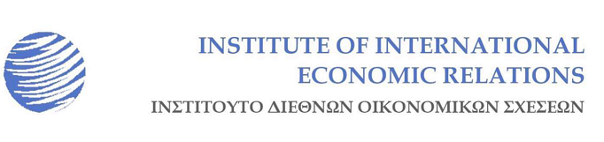
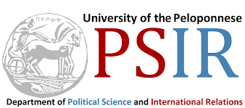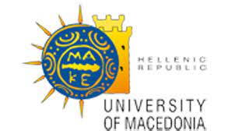
Department of
International and European Studies

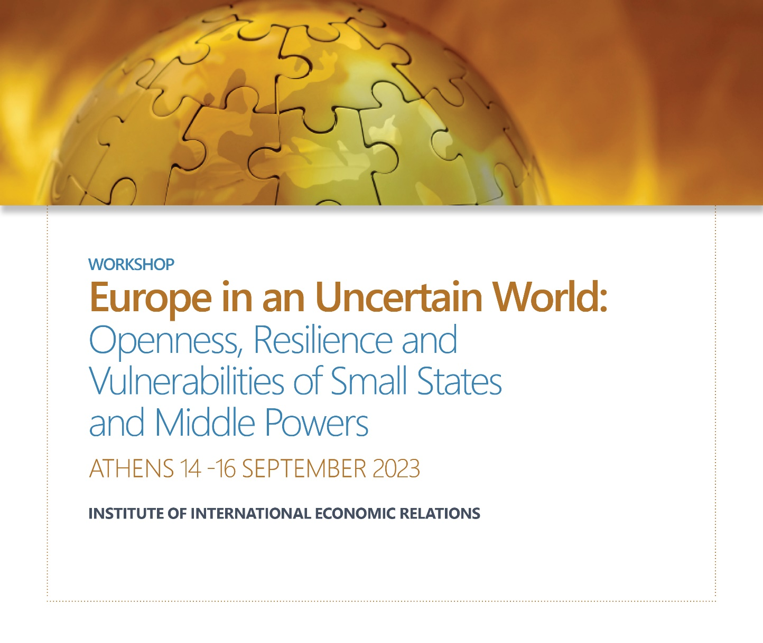

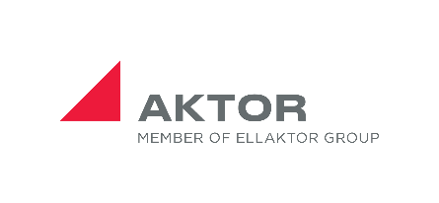

Programme

Workshop
Europe in an Uncertain World: Openness, Resilience and Vulnerabilities of Small States and Middle Powers

14-15-16 September 2023
Athens, Greece

Venue: 16, Panepistimiou St. (El.Venizelou), 2nd floor

The workshop is organised by the Institute of International Economic Relations (IIER) (Research Programme on the Theory and Practice of International Relations) in collaboration with the following institutions:

- Neapolis University Pafos, Cyprus
- Institute for European Studies, University of Malta
- Department of Political Science and International Relations,
University of the Peloponnese, Greece
- Department of International and European Studies,
University of Macedonia, Greece

Thursday, 14 September 2023

Venue: Institute of International Economic Relations (IIER),
16 Panepistimiou St., 2nd Floor, Athens, 106 72.

11:30-12:00: Arrival and Registration

12:00-12:30: Welcome Remarks

12:30- 14:30: OPENING SESSION: Europe at a Crossroads

Chair: Prof.Charalampos Tsardanidis, Director of the Institute of International Economic Relations (IIER), Athens.

Keynote Speech 1:
- Prof. Frank Barry, MRIA, Chair of the International Business and Economic Development Department of the Trinity Business School, Trinity College Dublin, Dublin: Reflections on Ireland's Journey from Agricultural Satellite of the UK to Modern European Economy.

Keynote Speech 2:
- Prof.Alfred Tovias, Emeritus, Department of International Relations of the Hebrew University of Jerusalem, Jerusalem, EU Foreign Policy on the Israeli- Palestinian Conflict: A Re-evaluation.

Keynote Speech 2:
- Mr. Dimitrios Kourkoulas, Former Deputy Minister of Foreign Affairs of Greece, Responsible for European Affairs and Economic Diplomacy. The Role of Small and Micro States in the EU: Resilience and Vulnerabilities.

14:30-16:00: Buffet Lunch

16:00-18:00: PANEL 1: The New Security Architecture in the European Landscape

Chair: Ms. Effie Charalampaki, Head of the Research Program on the Theory and Practice of
International Relations (IIER), Athens.

- Prof. Spyridon L. Litsas, Department of International and European Studies, University of Macedonia, Thessaloniki: Quo Vadis Europa? New Role and an Upgraded Mission for the New Era Ahead.
- Assoc. Prof. Konstantinas Andrijauskas, Institute of International Relations & Political Science, Vilnius University, Vilnius: The Shifting Continental Security Architecture: Ukraine-Centered Multilateral Security Alignments in Europe.
- Asst. Prof. Kyriakos Mikelis, Department of International and European Studies, University of Macedonia,Thessaloniki: Oscillating Between Security-Seeking and Status-Seeking? Turkey’s Power Activism.

Friday, 15 September 2023

10:30-12:00: PANEL 2: Shelter-Seeking Strategy of Small States

Chair: Asst. Prof. Hillary Briffa, Asst. Director of Center for Defense Studies, King’s College, London

- Prof. Baldur Thόrhallsson, Research Director, Centre for Small State Studies, University of Iceland, Reykjavik & Thomas Stube, Researcher, Faculty of Political Science & Centre for Small State Studies, University of Iceland, Reykjavik: Shelter-Seeking Strategy of Sweden and Finland: From the Beginning of the Cold War to NATO Membership.
- Prof. Charalampos Tsardanidis, Director, Institute of International Economic Relations, Athens,: The 2008 Economic Crisis in Cyprus: A (De)Europeanization or a Shelter-Seeking Strategy?
- Ms.Effie Charalampaki & Mr.Kostas Pechynakis & Ms.Nefeli Athanasaki & Mr.Giorgos Fragkos & Mr.Valasis Simitsis, Research Program on the Theory and Practice of International Relations, Institute of IEER, Athens: Small States as Agents of Change and Innovation in the European Space: The Cases of Ireland, Greece, Cyprus and Iceland.

12:00-12:30: Coffee Break

12:30-14:00: PANEL 3: The Parliamentary Diplomacy of Small States and Microstates

Chair: Mr.Stelios Stavridis, ARAID Senior Research Fellow, University of Zaragoza, Zaragoza.

- Prof. Roderick Pace, Institute for European Studies, University of Malta, Valletta: The Parliamentary Diplomacy of Small European States: Ordained to Remained Peripheral?
- Adj. Prof. Jordi Xuclà, Department of Communications and International Relations, University Ramon Llull, Barcelona: A Panoramic View of the Parliamentary Diplomacy of European Microstates: The Cases of Andorra, Monaco and San Marino.
- Ms.Laura Gil-Besada, Doctoral Researcher, Chair of Legislative Studies, University of Luxembourg, Luxembourg: The Parliamentary Diplomacy of a Small State in the Context of the Russian Invasion of Ukraine: The Case of Luxembourg.

14:00-15:30: Buffet Lunch

15:30-16:30: PANEL 4: The Relationship of Small and Middle European Powers with China

Chair: Prof. Roderick Pace, Institute for European Studies, University of Malta, Valletta

Adj.Lecturer Thrassy N. Marketos, Research Associate/Eurasia Energy Geopolitics, Department of Economics and Technology, University of the Peloponnese, Tripoli: Turkey’s Middle Power Pendulum: “Middle Corridor’s” Project Coupling with China’s “One Belt-One Road” Initiative in Eurasia.
- Mr.Edoardo Lavezzo, Ph.D. Candidate, Department of Politics, Derwent College, University of York, York/ Heslington: Turkey’s Behavior as a Middle Power: Navigating in the EU-China Competition through Transactionalism.

16:30-17:00: Coffee Break

17:00-18:30: PANEL 5: Uncertainty, Innovation and Vulnerabilities: The Challenges for
Small States

Chair: Ms. Effie Charalampaki, Head of the Research Program on the Theory and Practice of
International Relations, IIER), Athens.

- Mr. Georgios Alexopoulos, Ph.D. Candidate, Department of Social and Educational Policy, University of the Peloponnese, Corinth: Uncertainty Development Models in the Insecurity Period of the Eurozone.
- Ms. Korina Asteriou, Ph.D. Candidate, Department of International and European Studies, University of Macedonia, Thessaloniki: Small States and the EU Policy-Making Process: The Case of the 2015 Refugee Crisis.
- Mr. Georgios K. Papadimitriou, Ph.D. Candidate, Department of International and European Studies, University of Macedonia, Thessaloniki: At the Crossroads of Realism and Idealism: The States of the Scandinavian Peninsula and the Inevitable End of a Journey on Two Boats.

Saturday, 16 September 2023

10:00-11:30: PANEL 6: Small States and Middle Powers in the Baltics

Chair: Prof. Baldur Thόrhallsson, Research Director, Centre for Small State Studies, University of Iceland, Reykjavik

- Asst. Prof. Hillary Briffa, Asst. Director of Center for Defense Studies, King’s College, London: Confronting the Future: Cultivating Small State Resilience Through Strategic Foresight.
- Asst. Prof. Mariusz Antonowicz, Institute of International Relations and Political Science, Vilnius University, Vilnius: Small State and Middle Power Cooperation? The Comparative Analysis of Latvia’s, Lithuania’s and Poland’s Policies Towards Belarus After 2020.
- Ms. Andreea-Amalia Stănică, Ph.D. Candidate, National University of Political Studies and Public Administration (SNSPA), Bucharest: The Evolution of Society’s Perception of the Concept of Security in the Period 2013-2022 and the Influence of the Three Seas Initiative: The Case Studies of Romania, Poland and the Baltic States.

11:30-12:00: Coffee Break

12:00-13:30: PANEL 7: The Diplomacy of Middle Powers

Chair: Mr.Antonis Deriziotis, Lecturer, Department of Turkish and Modern Asian Studies, National and Kapodistrian University of Athens, Athens

- Asst. Prof. Karolina Gawron-Tabor & Asst. Prof. Joanna Piechwiak-Lamparska, Department of Political and Security Sciences, Nicolaus Copernicus University in Toruń, Toruń: Minilateral Defense Cooperation in Europe as a Tool for Small States.
- Nikolaos Vlahakis, Minister Plenipotentiary for Public Diplomacy, Embassy of Greece in Bucharest, Bucharest: The Soft-Power Strategy as the Optimal Choice for Small States and Middle Powers in the New Phase of Globalization: The Role of a New Public Diplomacy.
- Ms. Eleni Maria Kalafati, Instructor of Economics and Negotiations, City Unity College & Researcher in the Research Program on the Theory and Practice of International Relations, IIER,: Middle Powers and Inter-regionalism: The Case of MIKTA.

13:30:14:30: Buffet Lunch

14:30-16:30: PANEL 8: New Directions in the Diplomacy of Small Sates and Middle Powers

Chair: Prof. PanayiotisTsakonas, Department of Political Science and Public Administration, National and Kapodistrian University of Athens, Athens

- Associate Prof. Fotini Bellou, Department of International and European Studies, University of Macedonia, Thessaloniki: Greece’s Foreign Policy Response Towards the Blue Homeland Narrative: A Response from a Medium Power Facing Regional Revisionism.
- Adj. Prof. Jordi Xuclà, Department of Communications and International Relations, University Ramon Llull, Barcelona: Parliamentary Diplomacy as a Key Factor to Conclude the Monitoring Process of the Council of Europe in Andorra and Monaco.
- Ms. Georgia Manolopoulou, Ph.D. Candidate, Department of Political Science and International Relations, University of the Peloponnese, Corinth: From Identity to Prosperity: Revealing the Power of Cultural Diplomacy in Small States and Middle States. The Case Study of Greece and Italy.
- Ms. Aikaterini Patrikiou, MSc. International Negotiations, Athens University of Economics and Business, Athens: Navigating an Uncertain World: The Role of Diplomacy and Foreign Policy in Small States and Middle Powers.

