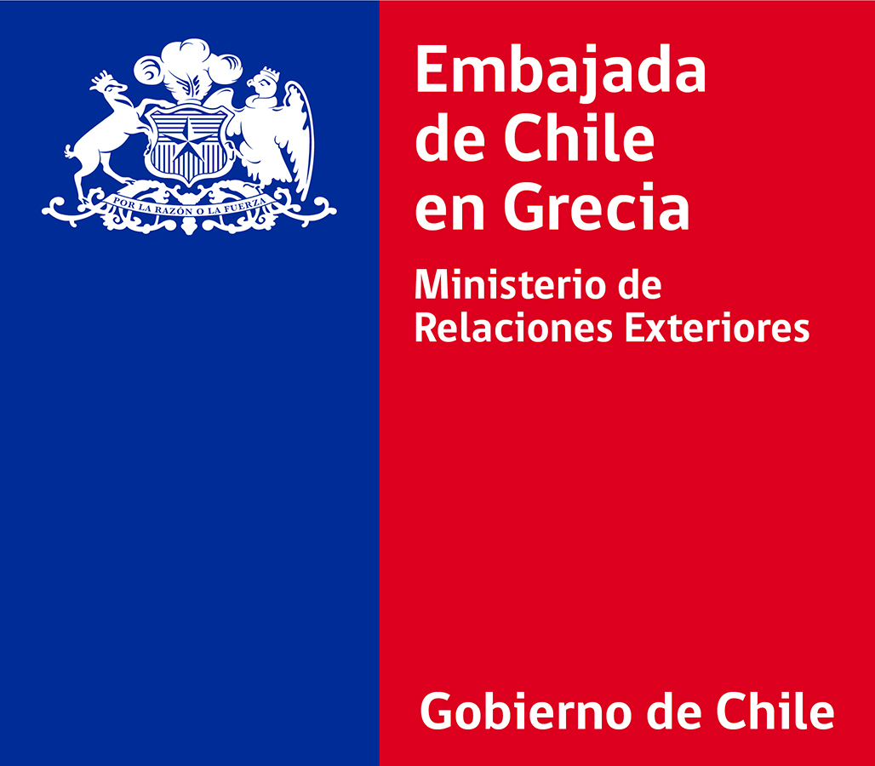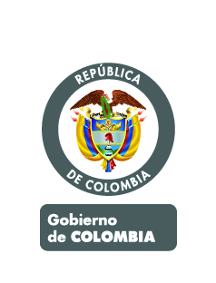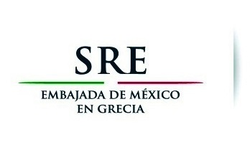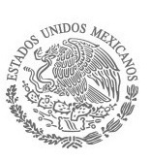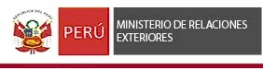
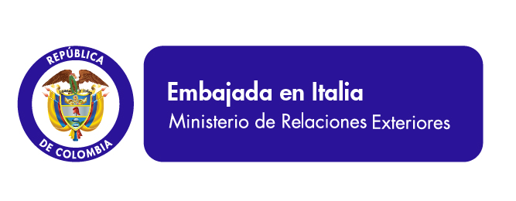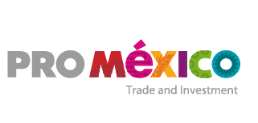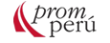

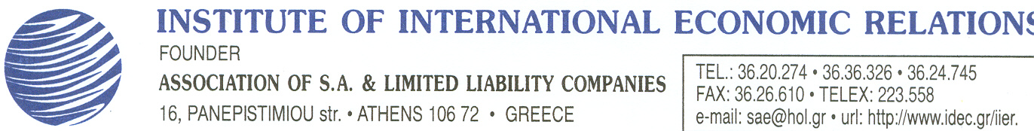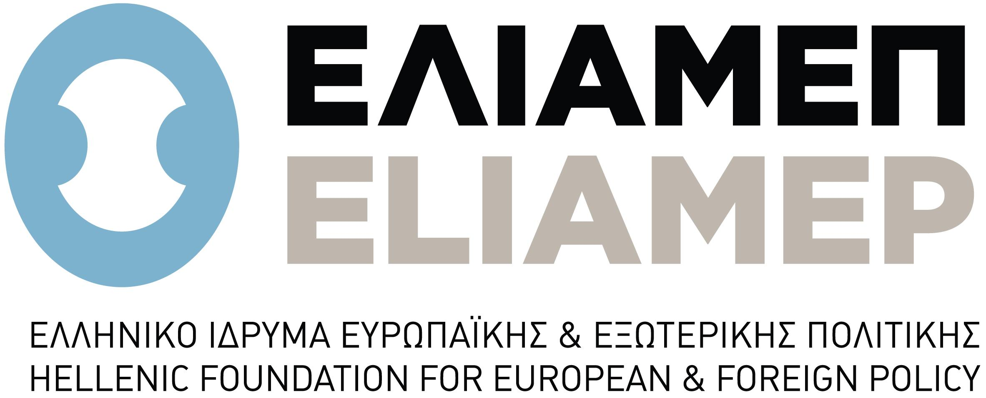

REGISTRATION FORM

20 November 2014

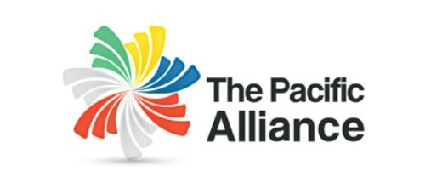
CHILE -COLOMBIA - MEXICO - PERU
Auditorium "G. Kranidiotis"
Ministry of Foreign Affairs of the Hellenic Republic
Akadimias 1, Athens
Thursday, November 20th 2014, 10.45 a.m.

Working Language: English
Information: Embassy of Mexico, Tel. 210 729 47 80 ext. 4
http://alianzapacifico.net/

THE PACIFIC ALLIANCE:

OPPORTUNITIES IN LATIN AMERICA FOR GREEK ENTERPRISES

Name:

Surname:

Organisation's Name:

Job Title:

Email:

Phone:

Mobile:

Please, fill in and send the Application Form to:

Email: sae@hol.gr FAX: 210.36.26.610

